**Student Response Systems**

**Final Project Report**

Submitted as partial fulfillment of the requirements for

ENGT 4050

Senior Technology Capstone

Professor Richard Springman

**Project Team B6**

Rodrigo Vega, Team Lead

David Pugh

Diego Rasgado

Ryan Rapini

Xiang Pan

Sercan Buyukkomurcu

**Faculty Advisor**

Dr. Weiqing Sun

April 25th, 2014

The University of Toledo

College of Engineering

Engineering Technology Department

This page intentionally left blank

An Abstract of

**Student Response Systems**

by

Team B6

Rodrigo Vega, Team Lead

David Pugh

Diego Rasgadp

Xiang Pan

Sercan Buyukkomurcu

for

ENGT 4050

Senior Technology Capstone

Spring Semester 2014

The University of Toledo

The primary objective of this project was to integrate the concept of the classroom “Clicker” devices used for quizzes, into a software format via a web application. Current clicker technology is limited to an expensive wireless device with basic numerical functionality as its defining feature. Transferring his concept to a format that can be used by mobile phones or computers will help to eliminate the need for any additional hardware or undue cost. This change also helps open possibilities to expand upon the features and functionality currently available in most current clicker devices, ultimately leading to a more interactive system for both teachers and students.

# Acknowledgments

Team B6 would like to acknowledge the following individuals whom in one way or other helped, supported, or contributed towards the success of this project:

**Dr. Weiqing Sun**, for taking the time to discuss the project as well as allowing us access to university facilities for team meetings.

Lastly the team would like to thank the multitude of resources available on the internet that helped, inspired, or encouraged the team towards the creation of a successful project.

Table of Contents

Acknowledgments iv

List of Figures vi

List of Abbreviations vii

Introduction 1

Project Objectives 1

Project Team 2

Design & Analysis 2

Results 10

Discussion & Conclusion 10

References 12

Appendix A A-1

Team resumes A-2

Appendix B B-1

Gantt Chart B-2

Appendix C C-1

Budget C-2

# List of Figures

|  |  |
| --- | --- |
| Figure 1: Home Page……………………………………………………………………... | 3 |
| Figure 2: Register User………………………………………………………………….. | 3 |
| Figure 3: New Teacher Page……………………………………………………………. | 4 |
| Figure 4: Create a Class…………………………………………………………………. | 5 |
| Figure 5: Select Class……………………………………………………………………. | 5 |
| Figure 6: View Classroom……………………………………………………………….. | 6 |
| Figure 7: Quiz Builder…………………………………………………………………… | 7 |
| Figure 8: Grade Book…………………………………………………………………….. | 7 |
| Figure 9: Student Register……………………………………………………………… | 8 |
| Figure 10: Student Dashboard…………………………………………………………. | 8 |
| Figure 11: Take Quiz…………………………………………………………………….. | 9 |
| Figure 12: Quiz Results………………………………………………………………….. | 9 |

# List of Abbreviations

|  |  |
| --- | --- |
| HTML……………………………………………...... | Hyper Text Markup Language |
| CSS..………………...………………...…………….. | Cascading Style Sheets |
| PHP..………………...………………...……………. | Personal Home Page |
| MYSQL………………...………………...…………. | My Structured Query Language |

# Introduction

The relationship between giving and receiving feedback has always been one of the central tenets of most student-teacher affiliations. A student is presented with information, and the instructor tests a student’s knowledge of that information in a meaningful manner. This practice allows for several different layers of information to be acquired. Does a student adequately understand the material? Is the instructor doing a good job of imparting the necessary knowledge? Is more time needed for certain areas of the subject matter? Many of these questions and more can be addressed with the appropriate cycle of giving and receiving feedback.

Technology has allowed us the opportunity to manifest more meaningful ways in which to complete this process. Currently the technology for most student response systems (commonly referred to as “Clickers”) is quite limited in terms of interactivity as well as functionality, and does not take advantage of the ubiquitous nature of the modern smartphone. This project’s primary objective was to explore the possibility of integrating clicker technology into a more accessible platform with the added benefit of more useful and responsive features for both teachers and students. This report will discuss our objectives for the project, design, analysis, results, team information, and other associated details.

# Project Objectives

The primary objective of this project was to investigate the possibility of using a smart phone in order to take the place of the traditional clicker device. In order to provide an opportunity for use to a wider audience, this was to be accomplished by means of a fully featured web application. The application was to utilize HTML & CSS to handle the frontend interface of the application, while the backend utilized MYSQL & PHP. Currently most clickers include simple functionality for multiple choice, true or false, numeric, and text entry. Extra functionality was also an objective that was to be taken into consideration as the more basic features of the application were incorporated.

The overall project can be broken up into three major component parts, the teacher section, student section, and the application database. These three components needed to work in concert in order to have a fully functional application. The teacher component was to be comprised of many different features in order to meet instructor’s needs. These features would include a login system, class management system, quiz creation system, grading functionality, and the ability to view rosters and grades. On the other side of the academic spectrum the student component of the application was to consist of a login system, class adder, personal grade book, and have quiz taking functionality. The database was to be comprised of the capability to store and order all data being used by both teacher and student components. This would include keeping track of grades, quizzes, teachers, students, and other user information. Beyond the primary objectives of the project, the vision for the project was to provide an alternative to a clicker device that would be economical, be simple to use, and have a consistent design and functionality.

# Project Team

The Student Response Systems project team is comprised of six students enrolled in the Computer Science Engineering Technology program at the University of Toledo. Three groups of two handled different aspects of the project with version control handled by Git via Source Tree. Source Tree allowed the group to collaborate efficiently, all work concurrently, and view their changes in real time allowing for a heightened sense of productivity. Group tasks were broken into three distinct categories involving the different aspects of the project. These categories involved the functionality and design for the student portion, teacher portion, and database portion of the application. One of each of the aforementioned groups was assigned one of these sections. Team members have all worked with the utilized technologies (HTML, CSS, MYSQL, & PHP) as part of their undergraduate education at the University of Toledo or as part of their jobs. This level of experience translated into a sense of confidence in all members abilities when it came time to assign the individual sections of the project. More information about each team member can be found in Appendix A.

# Design & Analysis

The initial design and concept for the site was a byproduct of a group brainstorming session in how to best go about implementing the service we intended to provide. The group settled on naming the application RocketQuiz, and registered the domain <http://www.RocketQuiz.us>. Several of the members had ideas for what they wanted the page to look like and the design went through several iterations until the group settled on the theme as pictured in Figure 1. This homepage welcomes the user to the page and includes information about the application, what it does, who it is for, and most importantly the ability to register in order to be able to use it. It is on this page that users are able to login or click the register button in order to sign up for an account. Besides entering basic information the user is able to choose whether they are a student or teacher(Figure 2). This distinction eventually dictates what services the user will be able to see and use once registration is complete, so it is important the user make the correct choice initially or they will have to register for another account in order to access the features or data they are looking for.

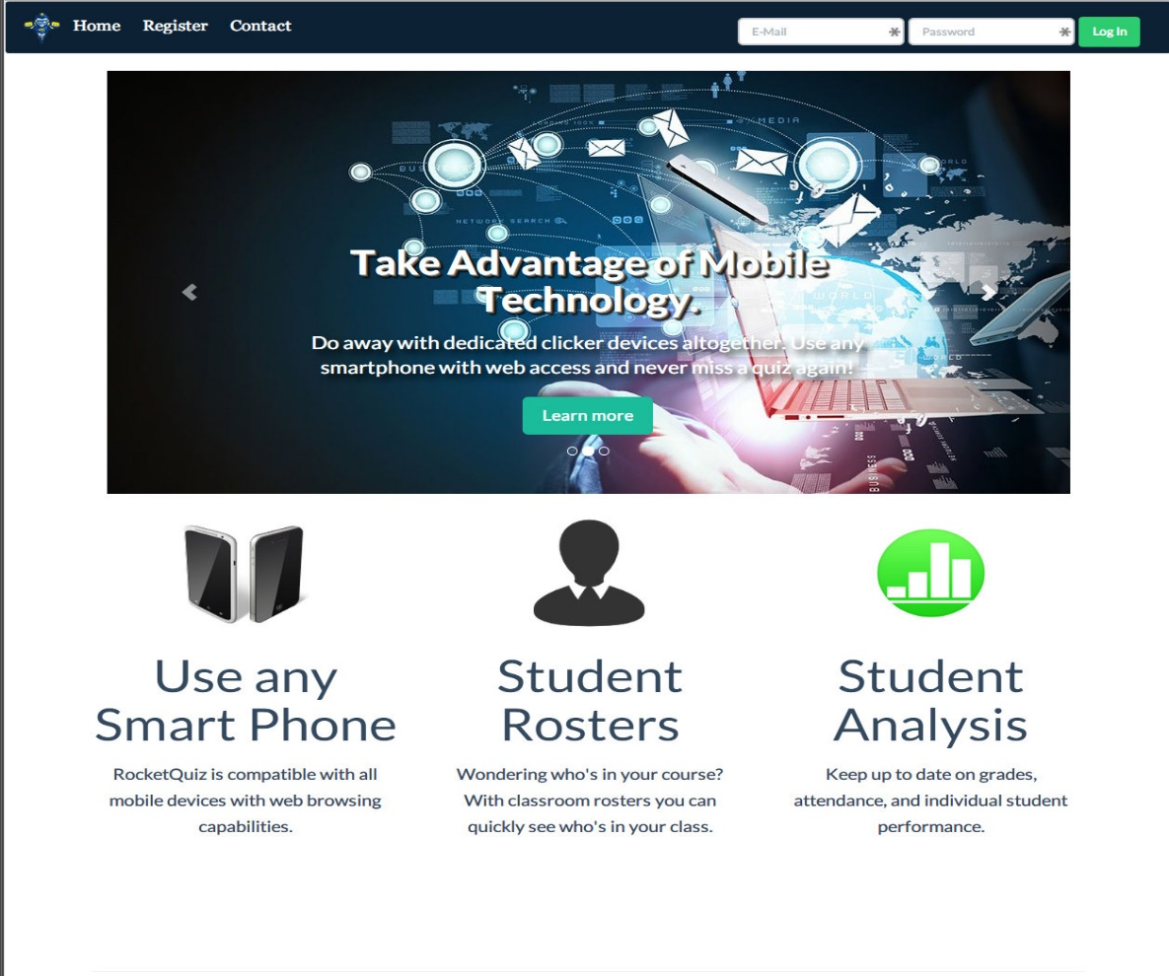

Figure 1: Home Page

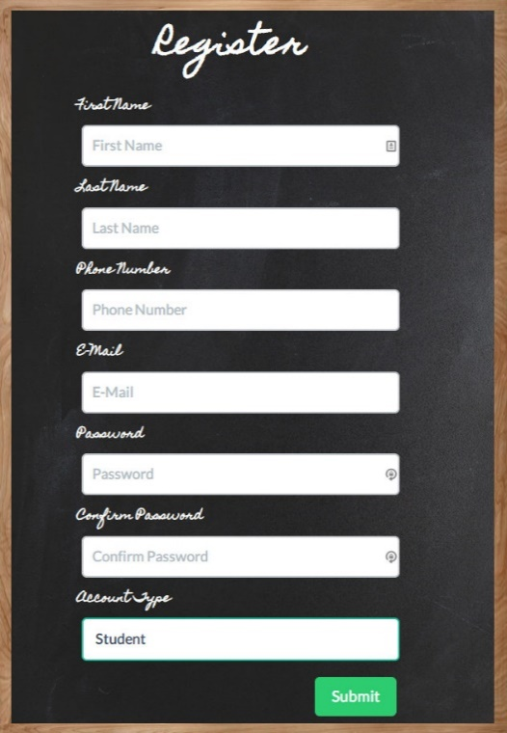

Figure 2: Register User

After registration is completed the user will then be able to use his details in order to log in. Upon logging in, if the user is registered as a teacher then they will be shown the teacher dashboard(Figure 3).This dashboard will provide access to the different services offered by the application, and provide a quick summary of these features. One thing to note is that if a registered teacher has not created a class yet then the features section will be greyed out (Figure 3).

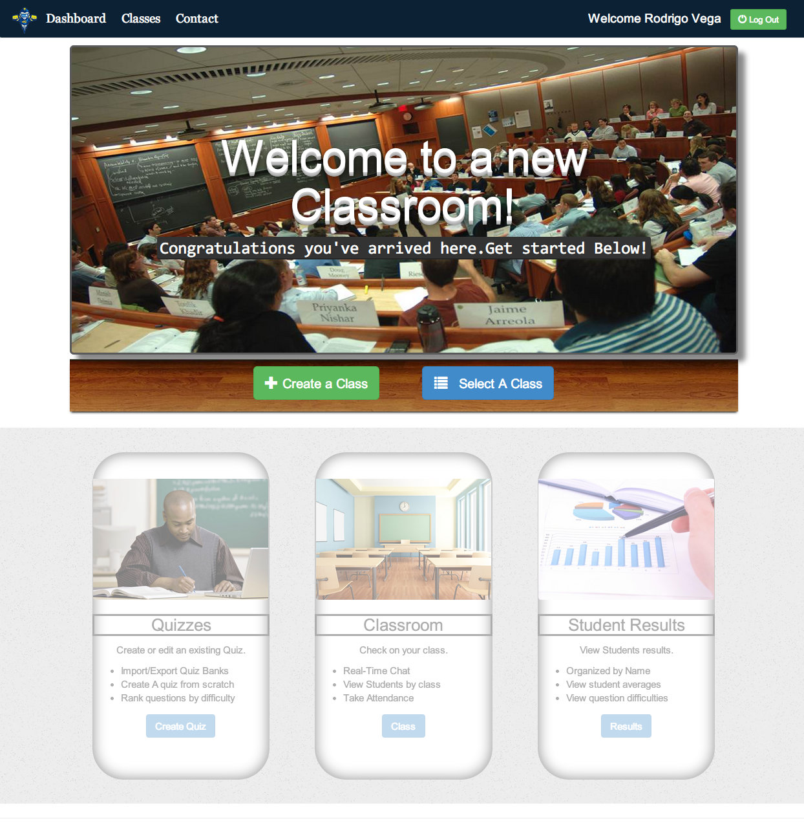

Figure 3: New Teacher Page

In order to create a class the registered teacher will click the green “Create a Class” button (Figure 3). Upon clicking the “Create a Class,” button the user will be presented with a page that prompts them to enter the subject of the class as well as the title of the class (Figure 4).

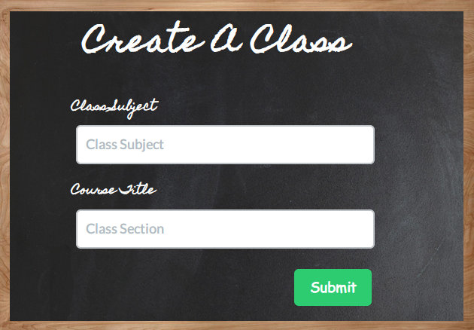

Figure 4: Create a Class

After creating a class the user will be returned to the main teacher dashboard, and from here they can select a class by clicking the blue “Select A Class,” button. After clicking the button they will be presented with a drop down menu from which they can now select one of the classes they have created (Figure 5).

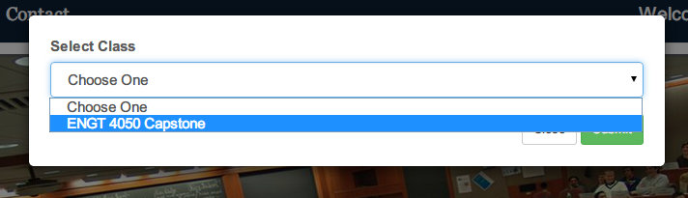

Figure 5: Select Class

Once the class is selected the Teacher dashboard will now allow the user to utilize some of the features notated at the bottom of the page. For example, once the user has selected a class, and clicked on the “Class” button they will be taken to a page that will display a class roster that shows all students registered for the class, (Figure 6). This pane will also go into detail about the quizzes that have been created for the class, when they were created and when they are due.

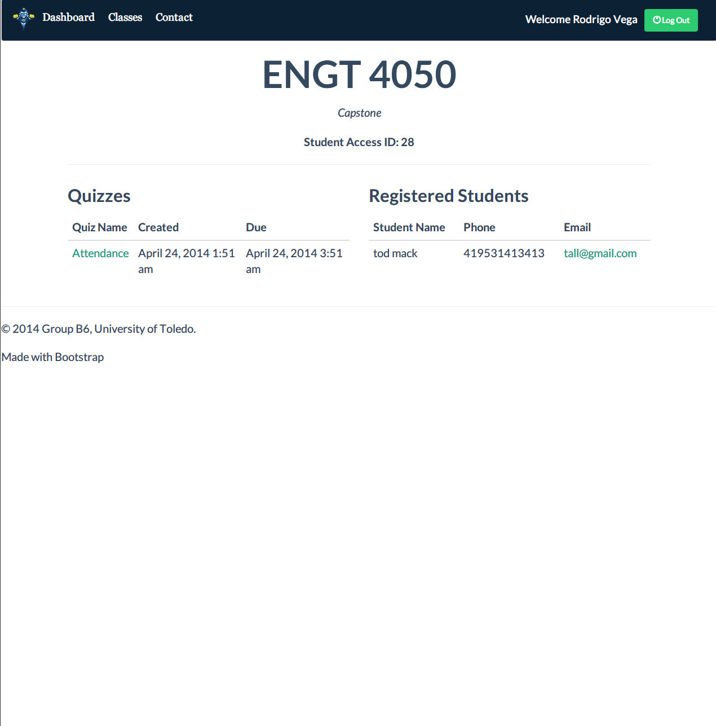

Figure 6: View Classroom

If the teacher returns to the main dashboard and then decides to click on the “Create a Quiz” button(Figure 3), they will be presented with the “Quiz Builder” feature of the application(Figure 7). The user can enter a name for the quiz, and then begin to fill in questions, and their subsequent answers. The correct answer for a question can be designated by clicking its corresponding checkbox. After the user is satisfied with his quiz they can save it by clicking on the “Save Quiz” button. After clicking the button the user will be sent back to the main teacher dashboard.

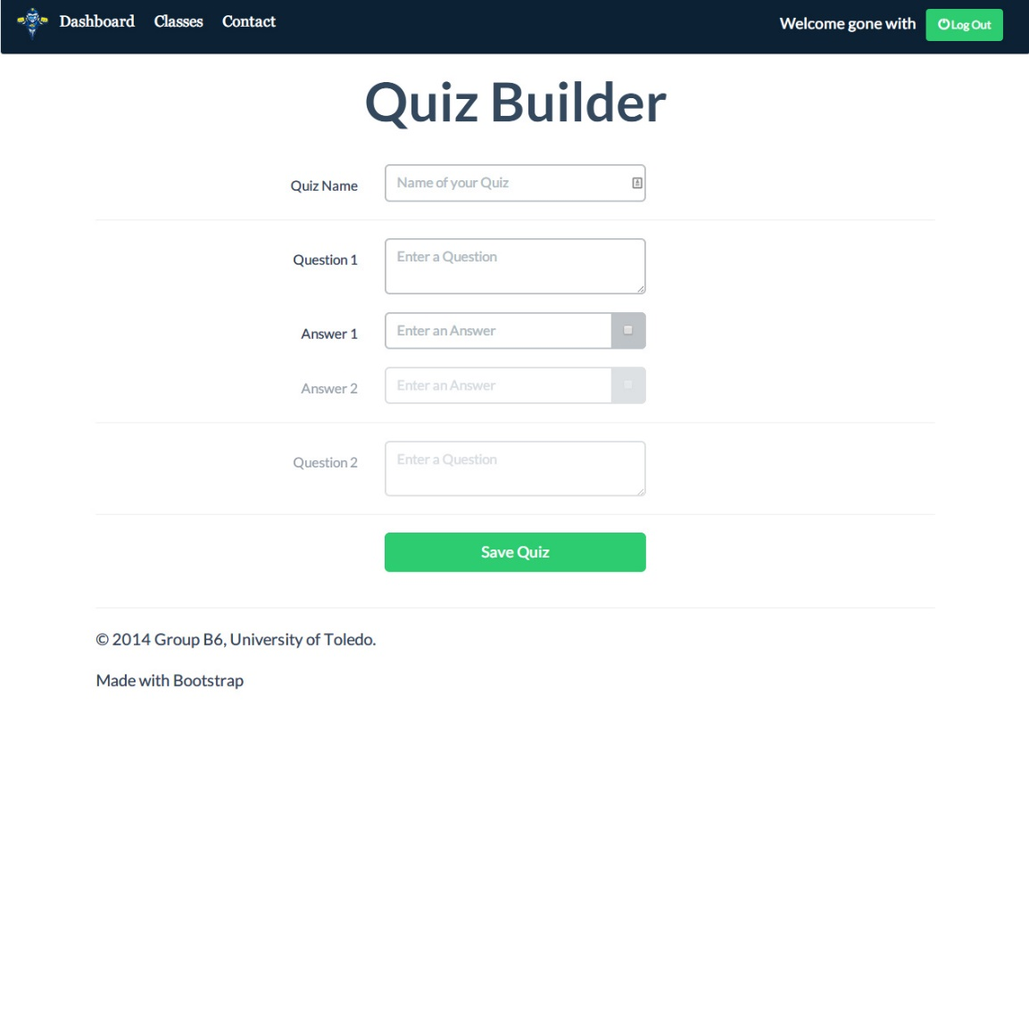

Figure 7: Quiz Builder

Finally, after returning to the teacher dashboard the user can click on the “Results” button, and view the class’s grades(Figure 8). Here the user can view the assigned quiz, who completed it, as well as their grade in points or percentage form. This concludes the teacher portion of the project.

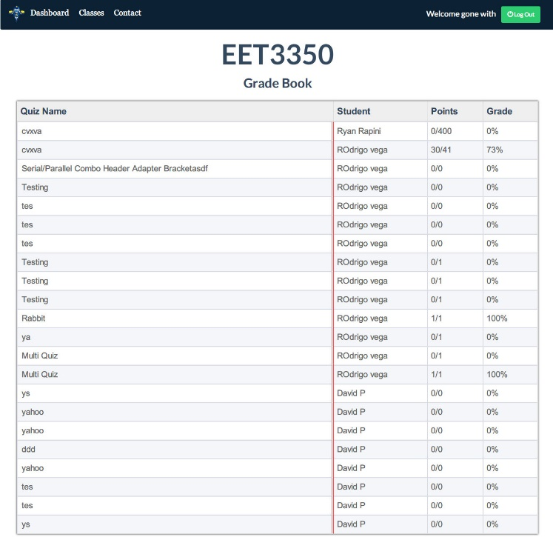

Figure 8: Grade Book

The student portion of the project is shown if the user registered as a student. When one of these users logs in they are met with the “Student Dashboard”(Figure 9). If the user has not yet registered for any classes they will be presented with the “Register” prompt. Here the user can enter an Access ID that is provided by the instructor, or they can manually search the drop down menu for their class. After either entering an ID or finding their class, the user can click submit to confirm their selection.

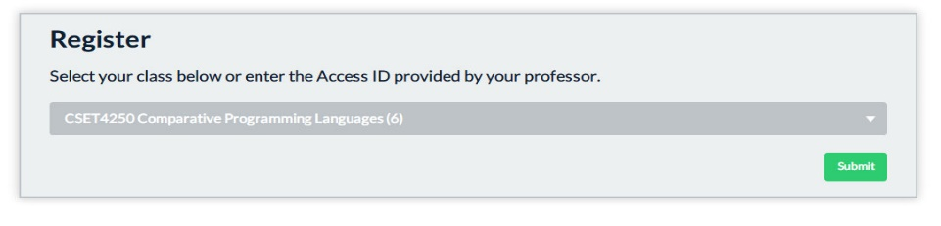

Figure 9: Student Register

After registering for a class the student dashboard will now provide the student with a list of the classes they are currently registered for. Students can view quizzes here as they are assigned. The name of the quiz, as well as due date, and grade(if the quiz has already been taken) will be located under the appropriate class header(Figure 10).

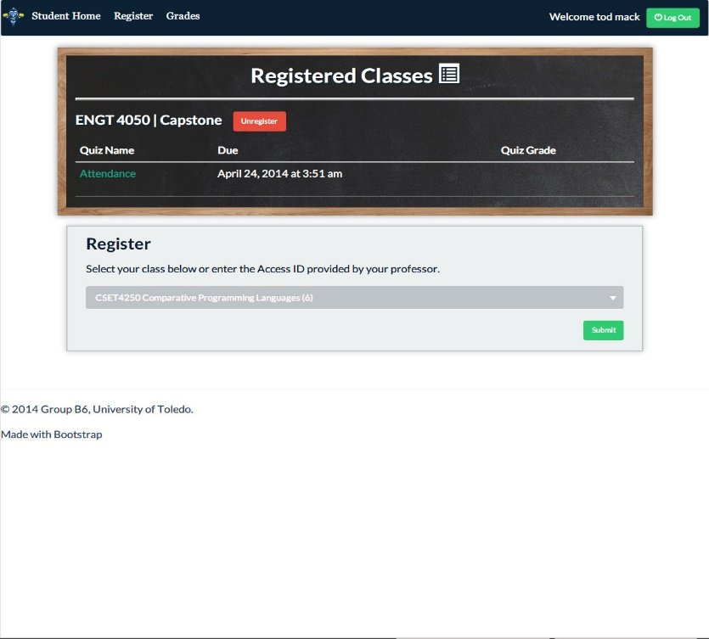

Figure 10: Student Dashboard

The user can begin to take a quiz by clicking on one of the quiz names located under the appropriate class. After clicking on the quiz name, the actual quiz will become available and the user will be able to answer the questions(Figure 11).

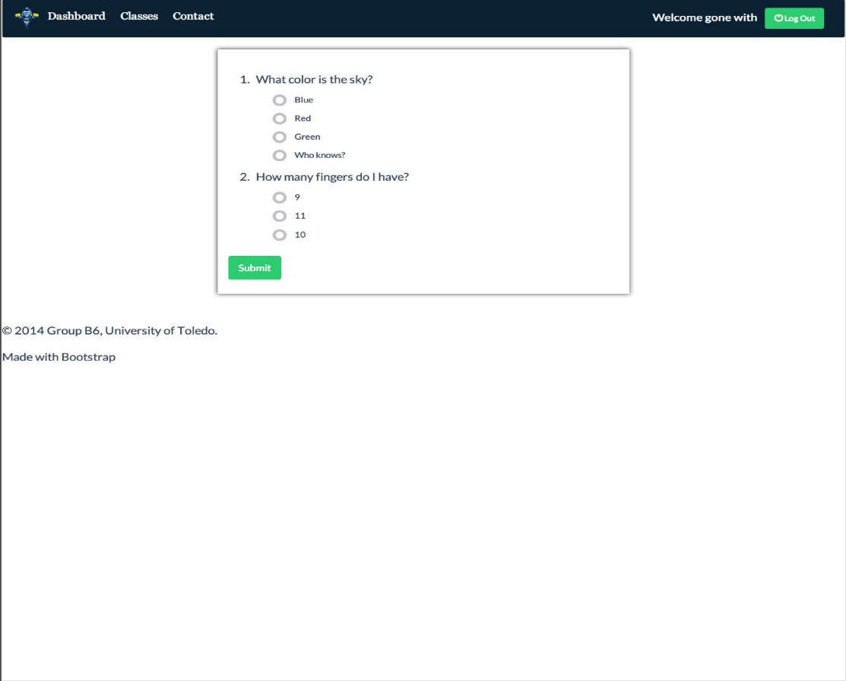

Figure 11: Take Quiz

After the user answers all of the questions and clicks the submit button, they will be taken to the quiz result section which will provide details about the quiz. Here the user will be able to see their grade, their points scored, the total quiz points, and what the correct answers were(Figure 12). This concludes the student section of the application.

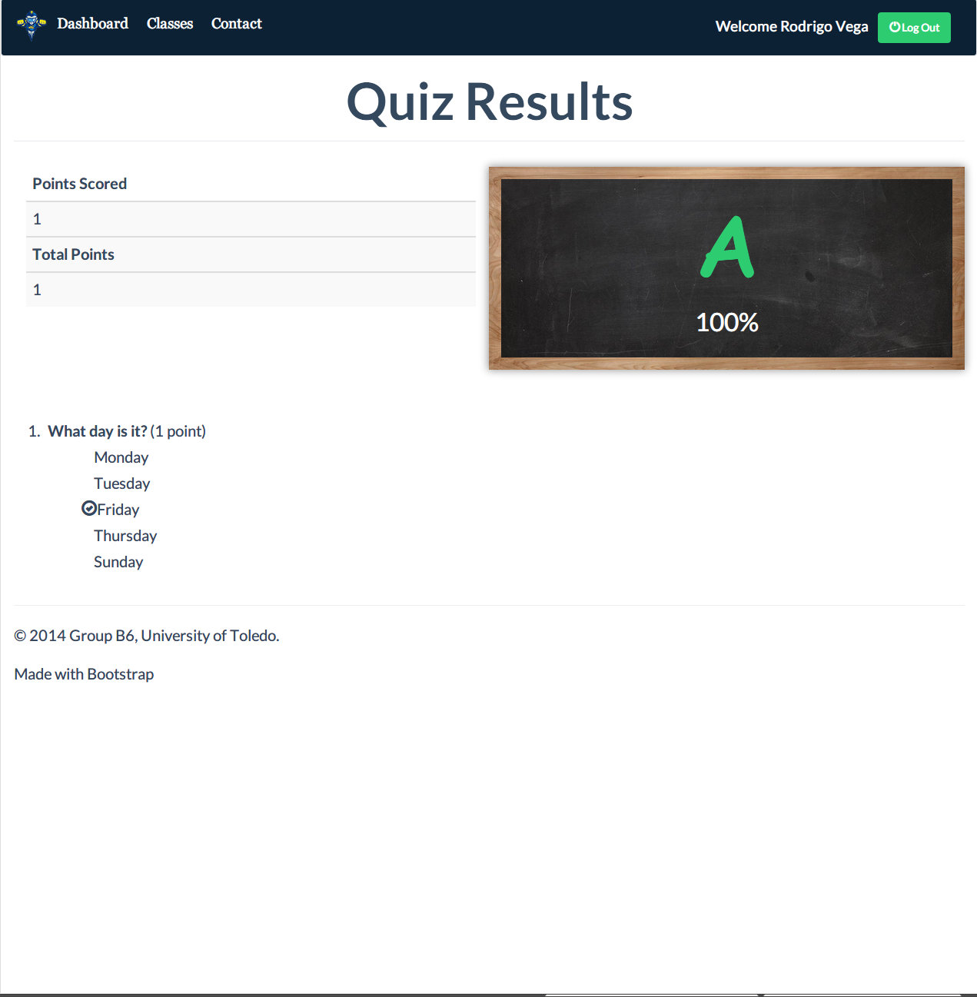

Figure 12: Quiz Results

# Results

In its current form RocketQuiz provides much of the functionality that can be found in present day clickers. When first visiting the website, users are presented with an option to login to their account or to register as a new user. When initially registering for an account, the user has the option to specify whether they are a student or teacher. Based on what the user has selected during the registration process determines whether they will be presented with the subsequent interface to operate as a teacher or student. If the user logs in as a teacher, they will be immediately presented with options and abilities to create classes, quizzes, and view subsequent details dealing with each of the aforementioned features. When a user logs into the application with a student account they are prompted to first register for a class if they are a new user. Once this is accomplished they are presented with the student dashboard. Here the user can see all of his classes, their associated quizzes, their due date, and his grade. He can also take quizzes from here by simply clicking on the name of the quiz.

Taking all of this into consideration the primary objectives were essentially reached, as they were mainly to see if traditional clicker devices could be “ported” to software, and if they could provide the same functionality. The project however was unable to really move into uncharted territory. This was for a couple of reasons, lack of time would be the obvious culprit, but there were also issues that were faced throughout the development process. Things such as miscommunication, poor labeling, and a lack of foresight when it came to accurately planning ahead for possible coding problems also played a hand. In spite of these things however, the group was able to build a solid foundation for an application that could perhaps take the place of clickers everywhere someday.

# Discussion & Conclusion

In its current iteration, RocketQuiz is barely scratching the surface in terms of the type of potential functionality and service that it could provide teachers, students, and institutions. Technology has become a very important part of the world we live in, and as its role in our lives continues to increase we have and will continue to find it widely embedded within the framework of our society and its institutions. As individuals attending university and studying in the field of computer science, our group finds a very interesting proposition presenting itself in terms of improving the quality of learning for students as well as helping teachers out in the classroom.

As with all things there can always be improvements, and this project is no exception. Some of the initially desired functionality, such as the ability to import or export shareable quiz banks, had to take a back seat to implementing the main features, so much so that this feature never saw the light of day. Like the feature just mentioned, there is also a long list of things that the group would have liked to have had the time to of implemented. This list ranges from a countdown timer for quizzes, to cheat detection, to a real time chat interface for students to communicate with their teachers.

In retrospect there were also many lessons learned throughout this project that will aid in future projects or on the job. Lessons such as choosing the right type of database for the job, how to successfully implement unique user sessions, or even just user design considerations were abound. However the most important lesson was in learning how to effectively collaborate as a team in order to see the project’s objectives accomplished.

In closing, effective feedback between students and teacher has long been considered one of the cornerstones of most forms of education. Through the introduction of Student Response Systems, better known as “clickers,” instructors are able to gather near instantaneous feedback from a lecture hall full of students. Current clicker technology is limited to an expensive wireless device with basic numerical functionality as its defining feature. This project aims to integrate this concept into a software format that is easily accessible by computer or mobile device thus eliminating the need for any additional hardware or undue cost. By transferring this concept to software it is also possible to expand upon the features and functionality currently available in most current clicker devices, and create a more interactive system for both teachers and students alike.

# References

Achour, Mehdi, Friedhelm Betz, Antony Dovgal, Nuno Lopes, Hannes Magnusson, Georg Richter, Damien Seguy, and Jakub Vrana. 2014. *PHP Manual.* The PHP Documentation Group.